Udemy Ethereum course Notes

Contents

Section 2 1

3. Why you should learn blockchain 1

4. Ownership, Possession and the Double Spending Problem 2

5 Ownership, Possession and the Double Spending Problem6.. 2

11 Behind the Scenes: Ethereum Transactions and Signatures, Private/Public-Keys 5

13 This is how Blocks are chained together: Cryptographic Hashing Explained 6

14… 6

15 Lab 6

16 Create your first smart Contract Explained! 7

17. Assignment: Create your first smart contract 9

18.. lab: Understanding blockchain nodes 9

19 Understanding Blockchain Nodes: Explained 9

20… 10

20. Assignment: Deploy Smart Contracts into Ganache 10

22. Lab: Variables – (Unsigned) Integers… 10

23. Lab: Variables: Boolean 10

24. Lab: Variables: - Understanding Integer Wrap 11

25. Lab: Variables: - Addresses and balances 12

26. Lab: Variables: - Strings in Solidity 12

27. Solidity Value type variables – Explained 13

# Section 2

## 3. Why you should learn blockchain

5 different companies looking for blockchain people

1. Start-ups (Angel list)
2. Corporate tech firms (IBM, Microsoft) (check blocktribe.com)
3. Banks
4. Governments
5. Professional services firm (e.g. The Big 4)

Requirements that they ask for

* Code in various languages (Java, C++)
* Comfortable with Large Data
* Understand Cryptography
* Understanding of the Blockchain

## 4. Ownership, Possession and the Double Spending Problem

Ownership is different from Possession

### 5 Ownership, Possession and the Double Spending Problem6..

What web 3.0 refers to:

Connective intelligence

connecting data

concepts application

If you understand google docs you can understand blockchain. In the sense that documents can be modified at the same time by people

1. Install Metamask

Went over what the other networks are. He uses the rapsten test network

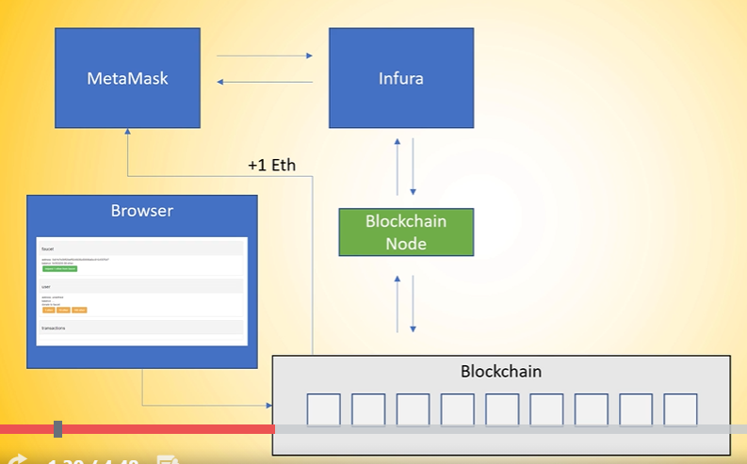

“Now that isn't so much magic. There is an actual service in the background that is called in Führer where a metal mass connects to and in in future is a block chain as a service provider and they internally have block chain nodes running in the background. And as you can see here we are installing meta mask, metal mask is actually interacting with Führer. They are hosting parody and go through some notes as far as I know and are opening a RESTful API in order for metal mass to interact with the block chain through a block chain note that they are hosting. Now the next thing that we did is we opened the fourth set like the mathematic falsetto here in the picture or maybe another faucet. It doesn't really matter. You open the browser. You hit some button and the browser through some magic interacted with the block channel and one ether or zero zero zero point zero five Gurley ether appeared you know a metal mask wallet. How is that possible. What happens in the background. There's also it's not rocket science. What is happening in the background the browsers interacting with some sort of backend and the backhand is interacting with the blocking or then sending off a transaction. The important part here is that the key the private key in order to sign this transaction and you're talking about transaction signatures in one of the next lectures the key is stored on the back end of that service that is providing this false set and this has access to the funds they are sending of a transaction from their address which is stored on the block chain ledger to the address that is stored in our mathematic wallet. And now as you can see here the ground truth is the block chain where it mathematic value in Europe by block should note has access to the blocks and data and the browser via the backend via the blocks the note has also access to the same block data. So we have one shared ledger across those two services. Now every time when we made a new transaction we opened the block explorer for the metal mask bug explorer. We were on the Robson test network that was Robson ethos candidate AOL. They are running a block explorer and on the girl it has network. It was Gurley thought if scandal. They all it's the same log explorer. Also no rocket science. They're either scan is interacting and hosting their own block channels and having a copy off the block chain locally on their data center and processing this block chain with all the transactions and showing us the result in the browser window. Now you can see here already. Every time we want to interact with the block chain we need a block to node and the block chain is the single source of truth underlying the data having stored there. Now you can imagine there is a lot more going on than not other nodes are interacting with the block. You know we can actually download our own node now which is going theorem or have a larger basal or parity and they are all doing pretty much the same thing. They are connecting to the block chain and starting to download the blocks locally. And in order for us to avoid this downloading for now we're going to do it later in the course but for now we just want to get started doing something with the block chain we can use services like in future to interact with the block chain by a hosted block channel. All right. What are the key takeaways here. The first thing is you need a block channel to interact with the block chain. This can be hosted node or your own node. In our case it was a hosted node they block chain is the single source of truth in the whole systemwhere we have a shared ledger across all participants which can get access to the same data. And there are infrastructure providers that abstract this running a block chain away from developers from users and make onboarding quite easy. All right. That's it for this lecture. And in the next one we are talking a little bit more about cryptography and transactions.“

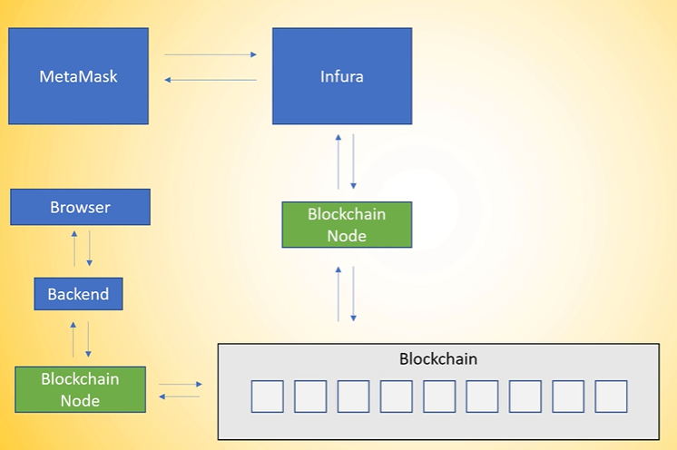

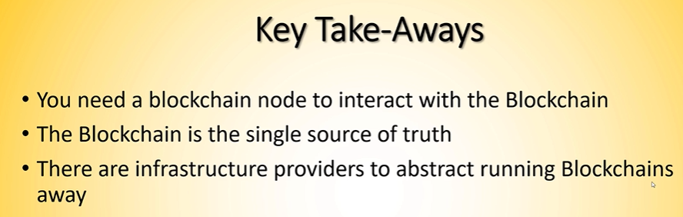

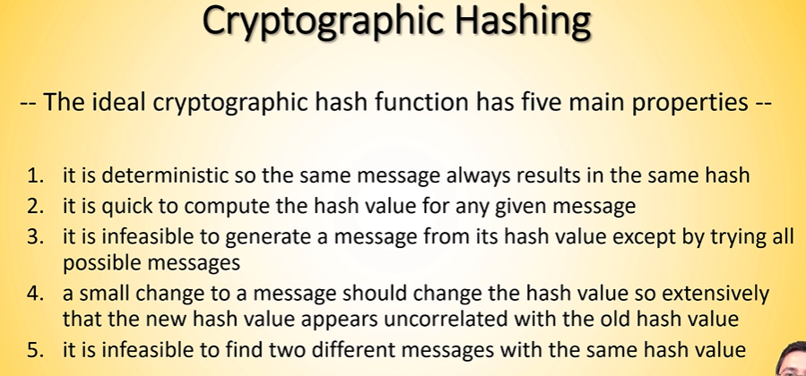

## 11 Behind the Scenes: Ethereum Transactions and Signatures, Private/Public-Keys

*He calls a transaction and object*

So every private key is hopefully different than the private key is sent through a function which is called ecliptic crafted signature algorithm and this is it is a function gives you a public key and the public key is a couple of properties. One of the most important property is you can create the public key from a private key but you cannot go back if you have a public key without trying all combinations.”

“Now we take this public key and we create an ethereum account that if their name account is the case like hash of the public key and then the last 20 bytes of that. So when you take a public key and you create a case like hash you take the last for the hex characters or the last 20 bytes.”

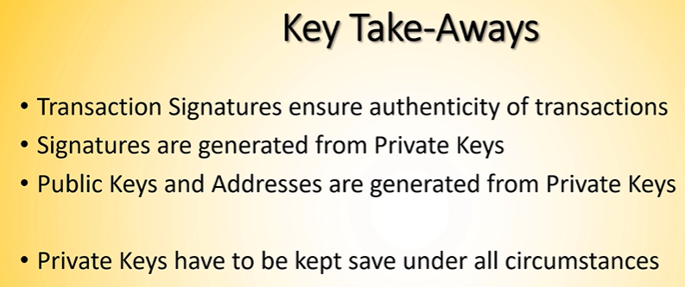

## 13 This is how Blocks are chained together: Cryptographic Hashing Explained

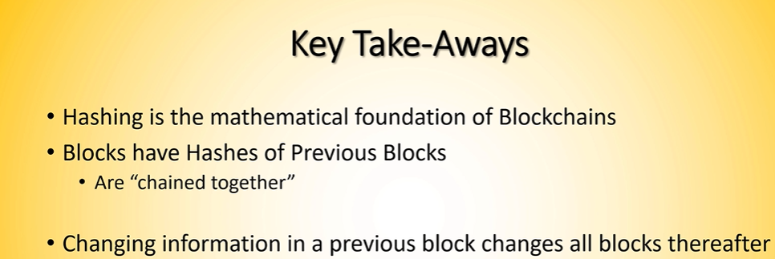

## 14…

Block height = the # of the block. Parent Hash = the hash of the previous block

## 15 Lab

A couple of ways to program solidity (e.g. Any text editor).

We will use **remix.ethereu.org**

Other smart contract languages: Vyper, LLL, Solidity

Vyper is less error prone than solidity

Every public variable will create automatically and get a function internally in solidity.

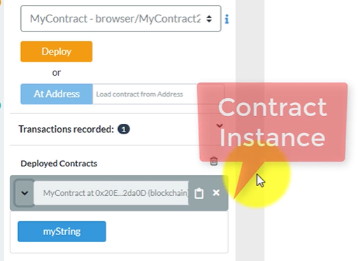

So when you hit my string you will see hello world and that's it.

## 16 Create your first smart Contract Explained!

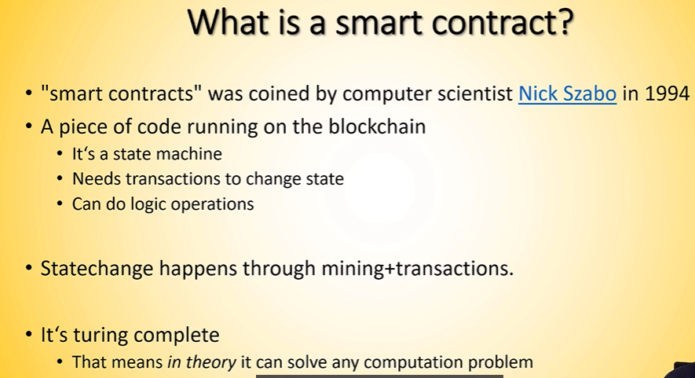

When code gets compiled from the languages above, what gets sent to the blockchain is EVM Bytecode.

Introduced the concept of Turing complete. Solidity is Turing Complete

If you deploy a smart contract if you're running a smart contract on the block chain then every participating node in the network executes that transaction and makes sure that the transaction is valid because every node in the block chain has a copy of the block tree and this is why it is one shared ledger across all participating nodes”

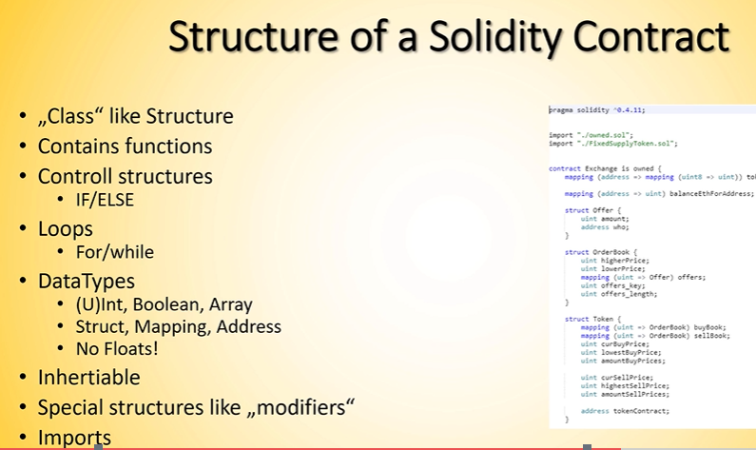

(I am pretty sure the 3rd to last bullet above should say “inheritable”)

Some general structure of a smart contract:

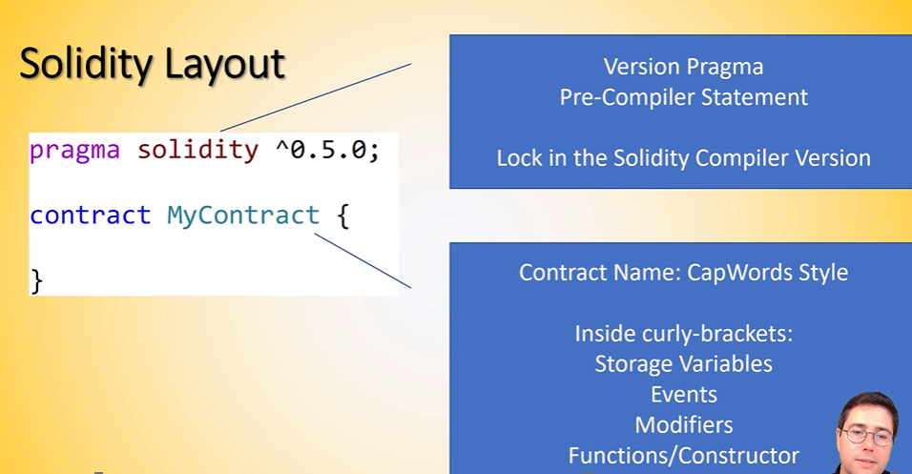

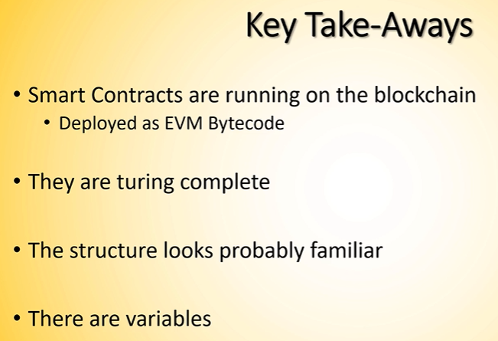

## 17. Assignment: Create your first smart contract

## 18.. lab: Understanding blockchain nodes

About the environments that can be selected in remix

**JavaScript VM**: “One is the javascript virtual machine and that is an execution environment that simulates a chain in memory of the browser.”

**Injected Web3:**

**Web3 provider:** This is the one that connects to Ganache I believe. “Blockchain node that is running externally”

## 19 Understanding Blockchain Nodes: Explained

Nodes that talk to each other can form a blockchain.

You can have a private/consortium network with nodes that speak through the Ethereum protocol but they can have completely different data. They can have some of the same data as the main network when you fork the main network

The only thing that needs to be configured when starting a blockchain is the genesis block

## 20…

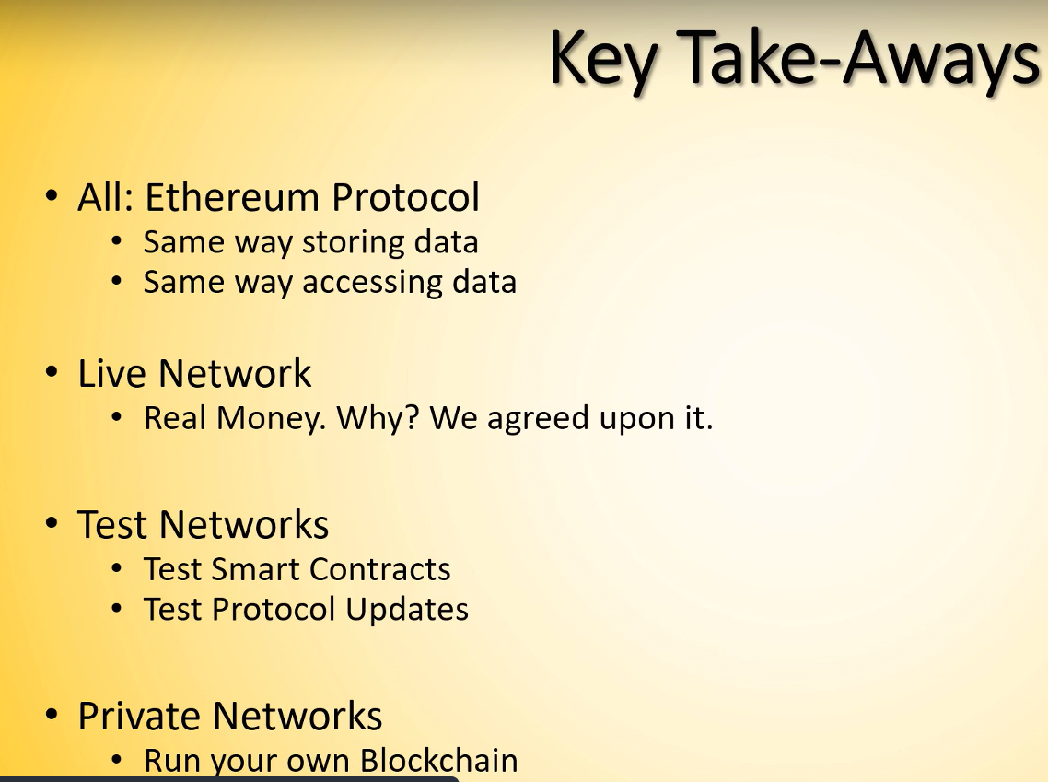

## 20. Assignment: Deploy Smart Contracts into Ganache

## 22. Lab: Variables – (Unsigned) Integers…

Actual hands on stuff

Did this:

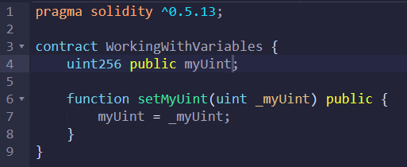

## 23. Lab: Variables: Boolean

Added this stuff:

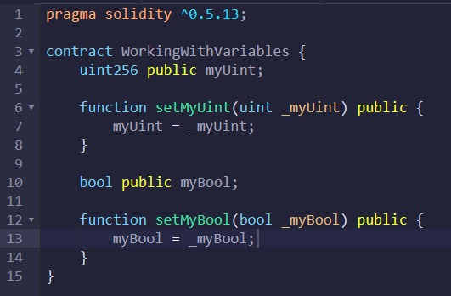

## 24. Lab: Variables: - Understanding Integer Wrap

Added this:

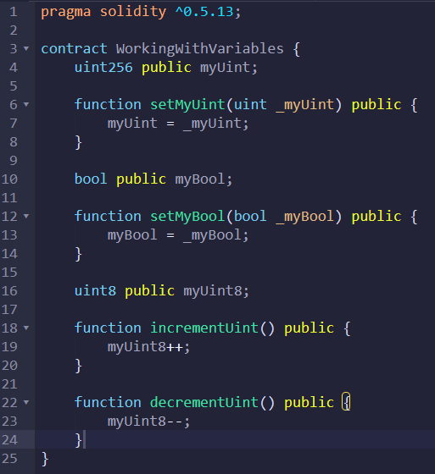

When you decrement below 0, the value you get will be 255

## 25. Lab: Variables: - Addresses and balances

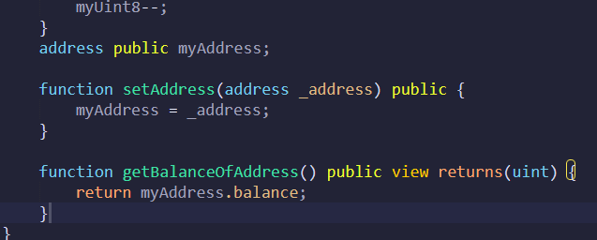

## 26. Lab: Variables: - Strings in Solidity

Strings are byte arrays

When we have a string we have to enter the “memory” argument inside the function because we have to specify where it is stored

It is not recommended to work with strings in solidity because they will cost you a lot of ether

You can’t concatenate or search for strings. Solidity is not made for working with strings

Added this:

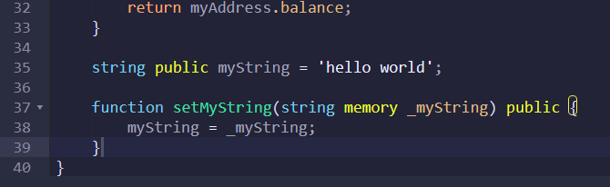

## 27. Solidity Value type variables – Explained

This will be a more theoretical lecture

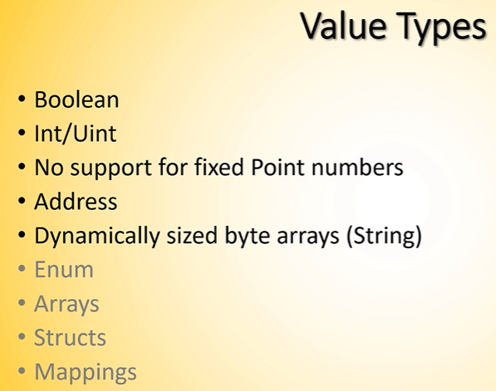

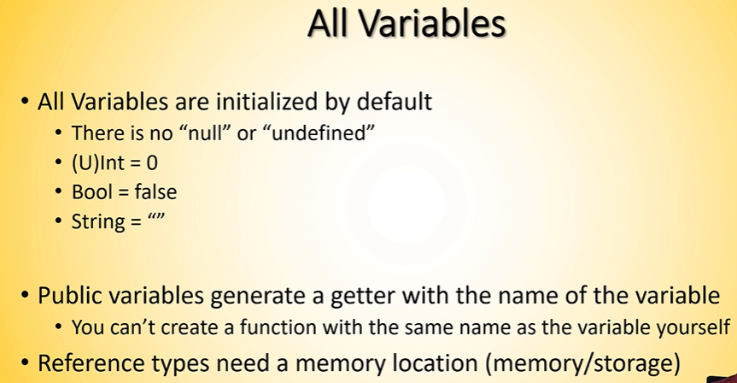

Boolean variable is initialized with “bool …”

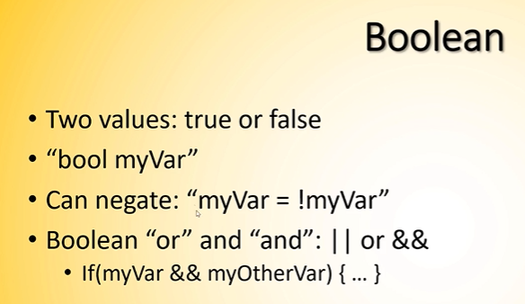

There is a typo below. The last number should be 255 not 256

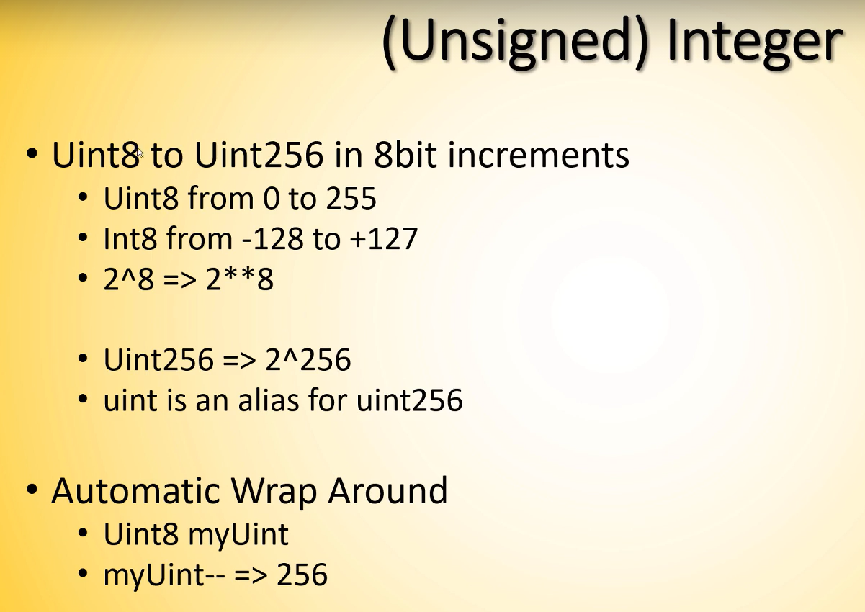

The below hasn’t been implemented yet, so he didn’t go over much

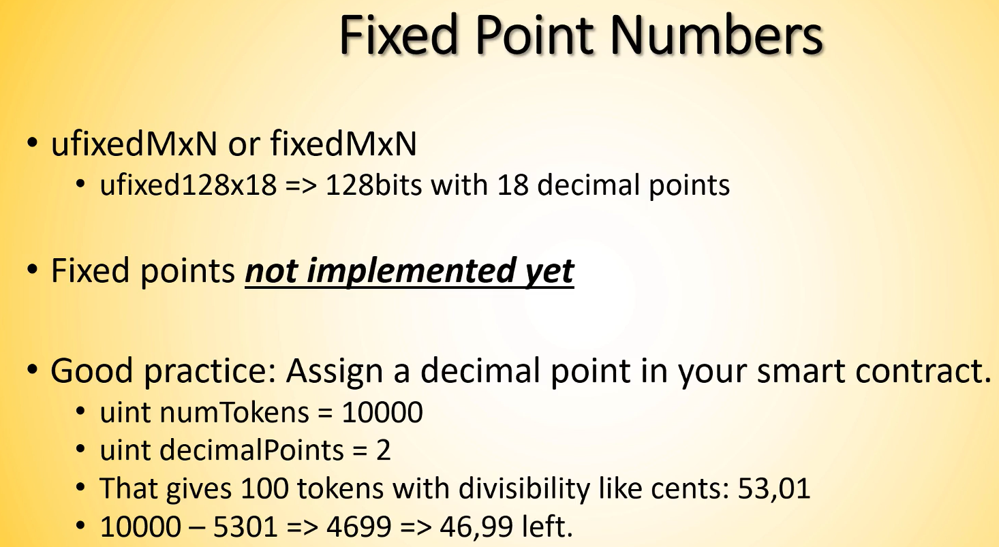

Addresses will be used mainly to send ETH

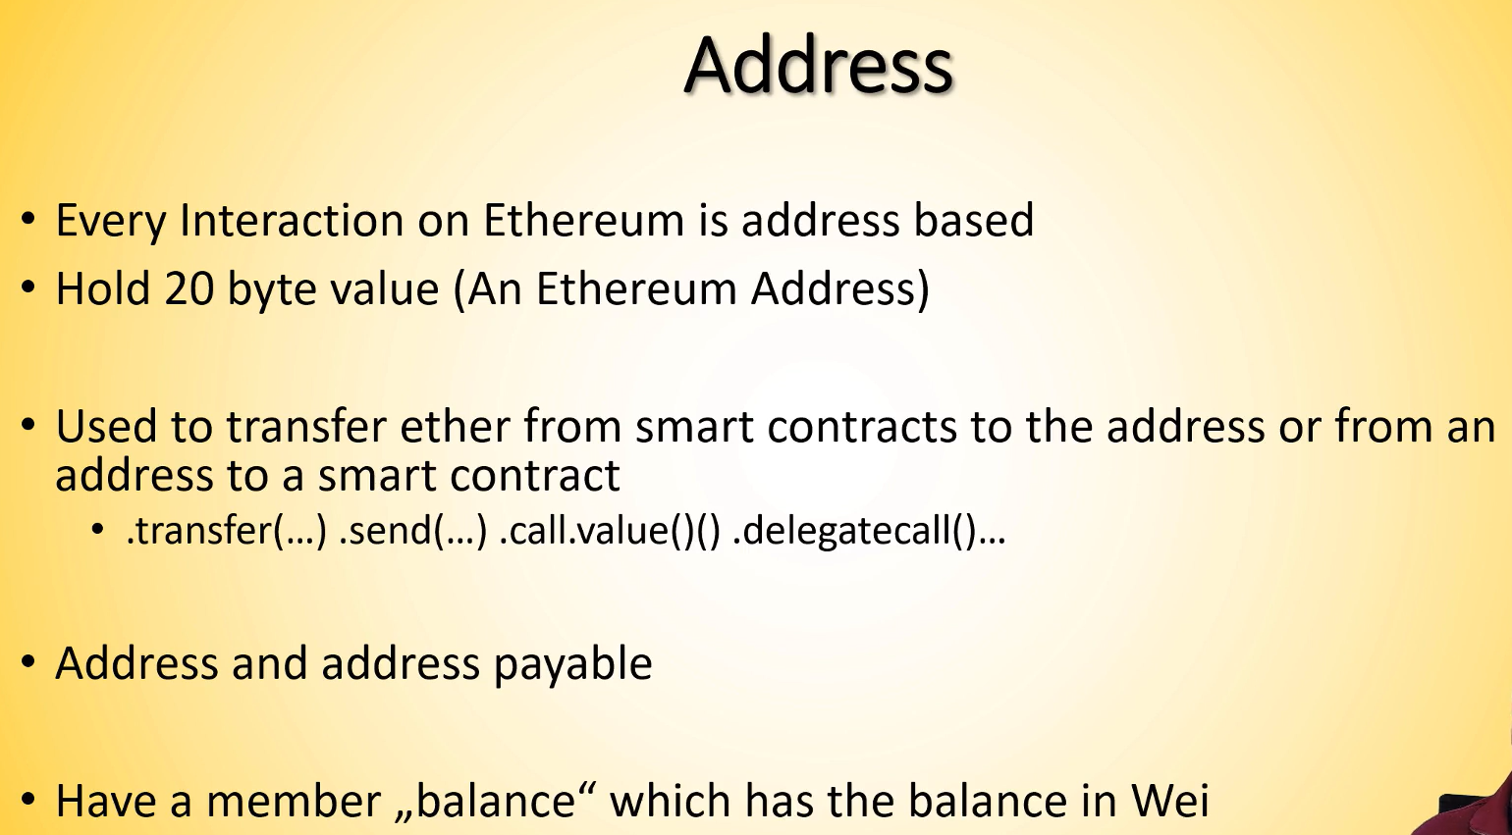

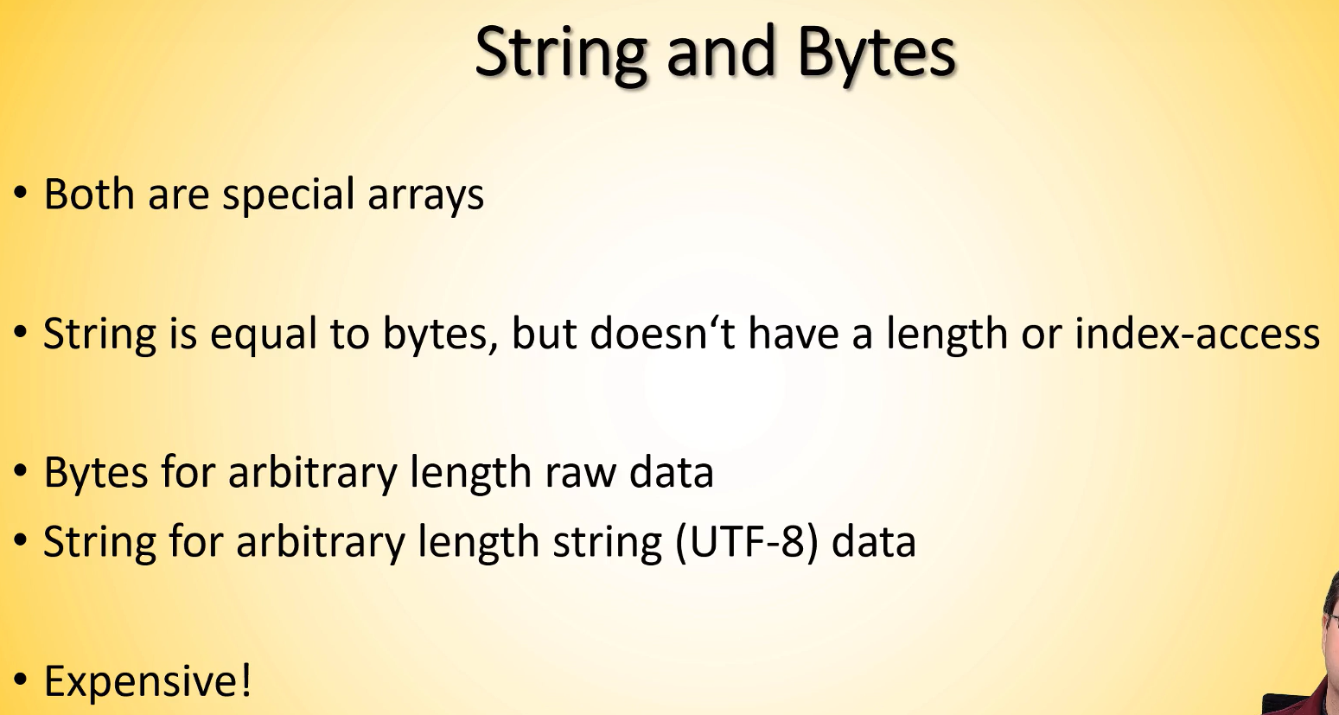

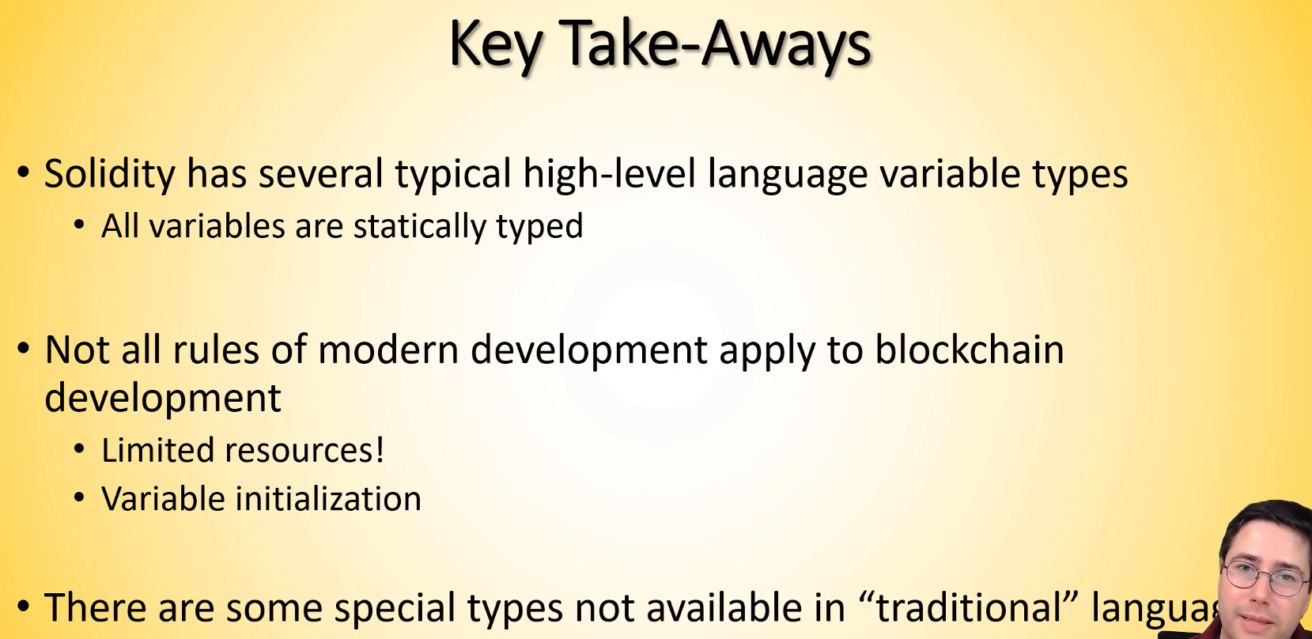

## 28: Assignment: Understand simple variables in Solidity

This lab is exactly what I had been following along in the previous lectures

## 29: Understanding addresses and the Msg-Object step by step

Now more details on how to transfer funds between addresses

When we know a contract is going to receive money we need to specify “payable” (after public)

This is what we did in this lecture

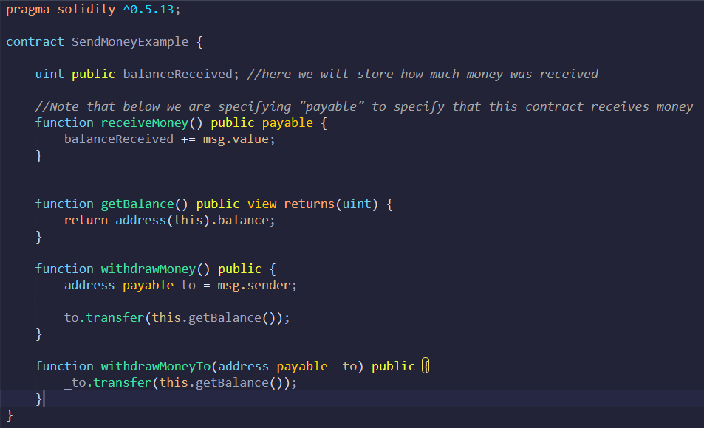

## 30 Addresses and the global Msg object – explained!

2 definitions

Externally Owned accounts (EOA): There is a private key behind. They are outside the Ethereum blockchain

Contract Accounts: These are inside the Ethereum Blockchain

Contract Accounts can’t trigger initial transactions

The Blockchain stores how much is stored in each address

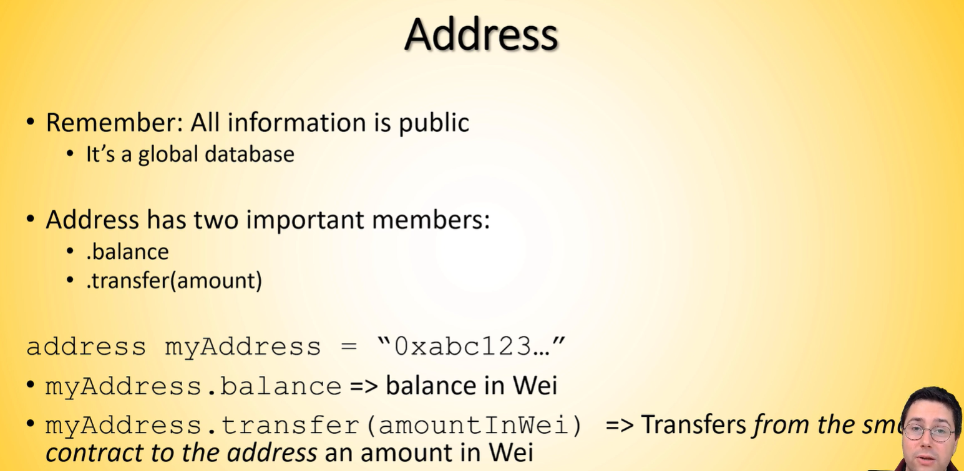

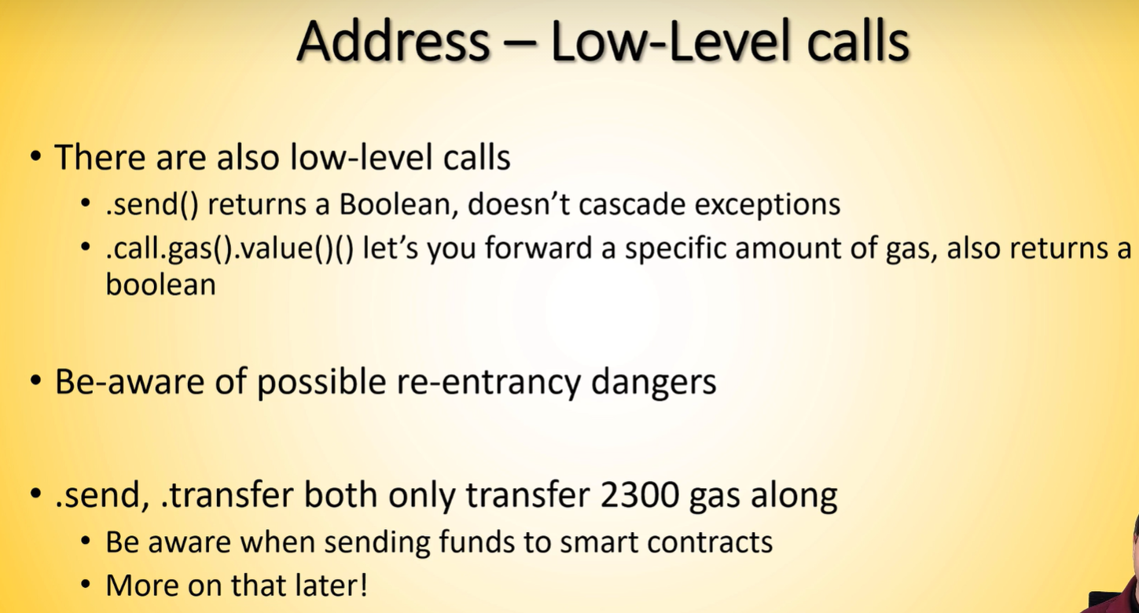

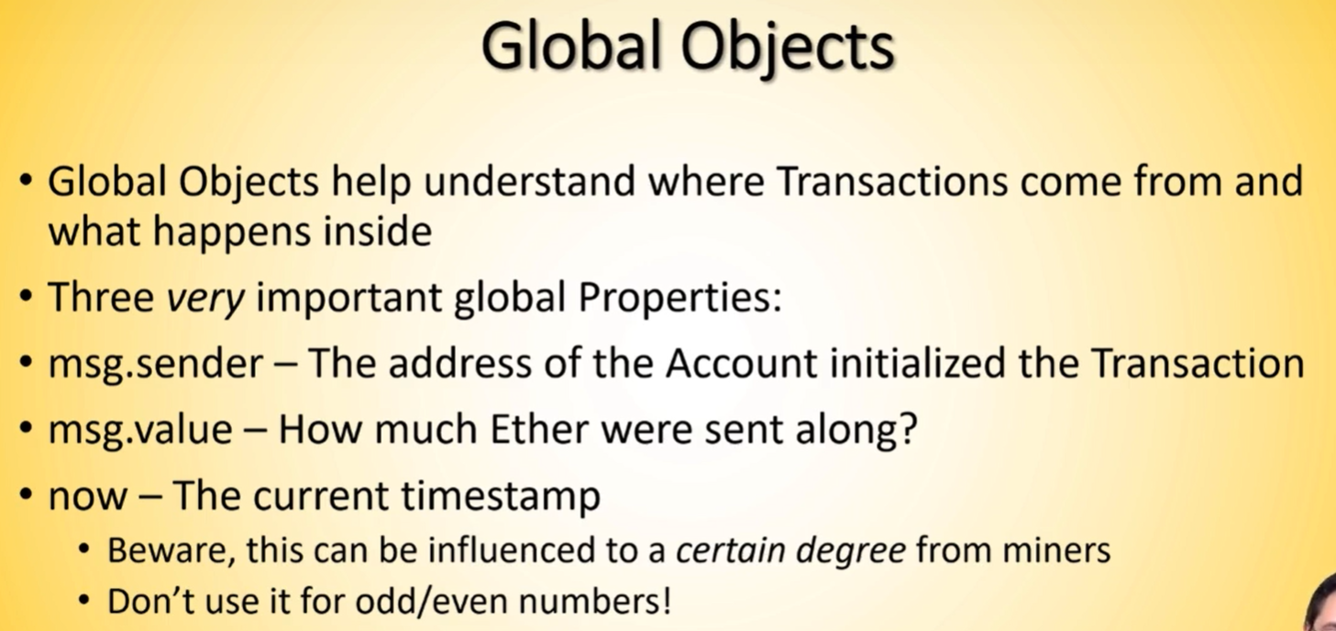

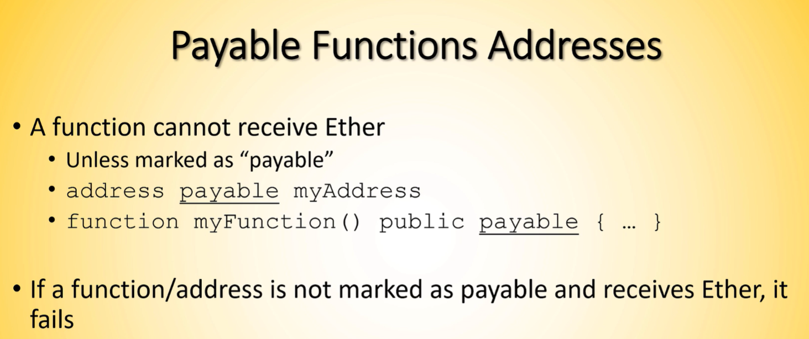

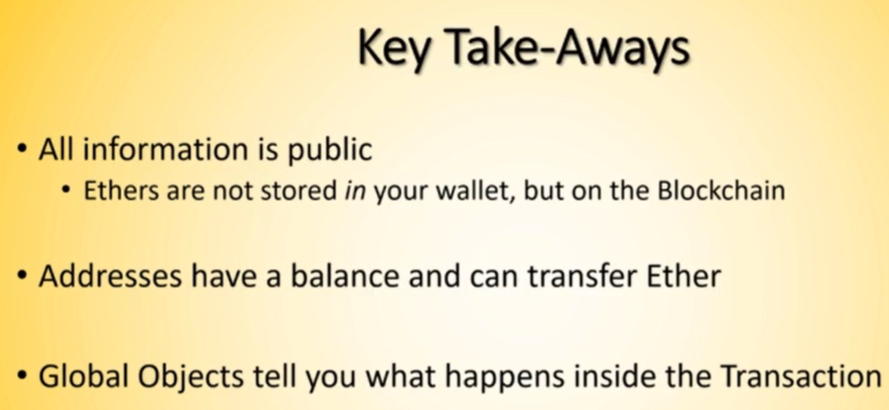

## 31: Lab – basically what I had already done before

## 32: Start, stopping, pausing, and deleting smart contracts